**Name:- Samreen Shaikh Roll no:- 64**

**Subject:- Big Data Analytics Date:- 04/03/2025**

**PRACTICAL - 17**

**MAP REDUCE**

**STEP I :*PRE-REQUISITES***

**a) Check Python Version 1.8 is installed in your system.**

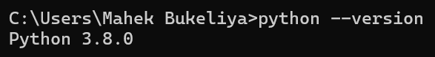

**STEP II: *Start Hadoop***

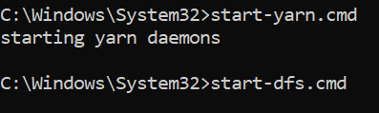

**STEP III: *Install package mrjob using pip.***

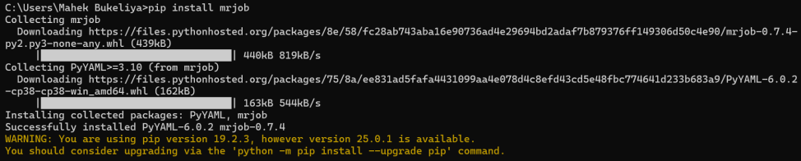

**OPERATIONS**

**1] WORD COUNT**

**Make a folder and create a python file and save the code in the file**

**CODE:**

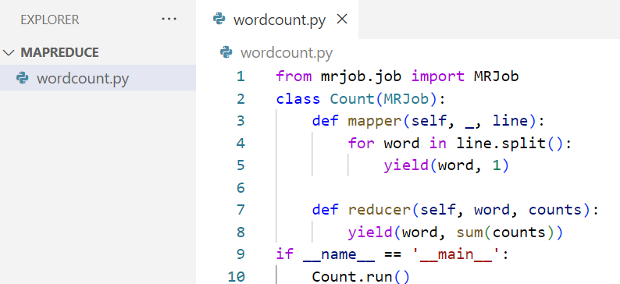

**Create a input.txt file in the same folder and type some contents in it to count.**

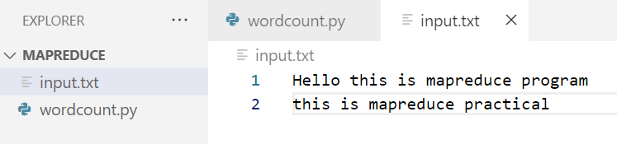

**Run the python file in the terminal using following command**

**OUTPUT:**

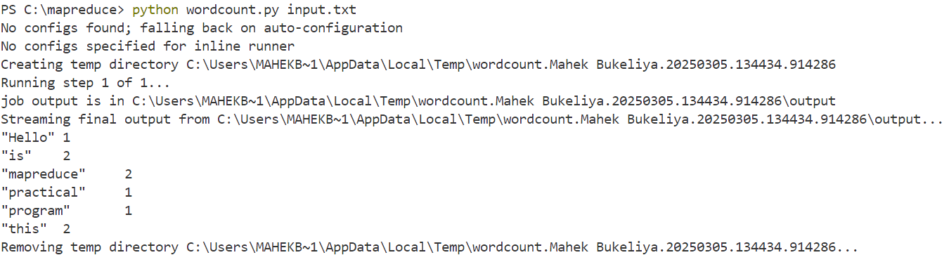

**2] COUNT CHARACTERS**

**CODE:**

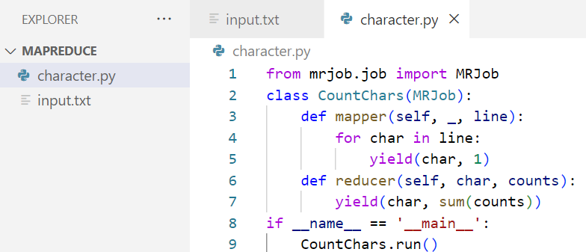

**INPUT FILE:**

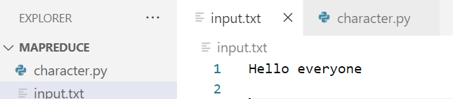

**OUTPUT:**

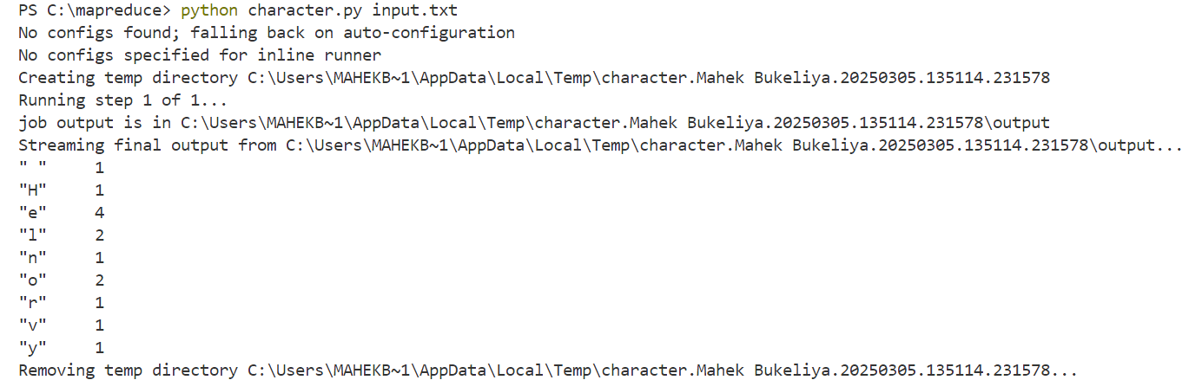

**3] MAXIMUM NUMBER**

**CODE:**

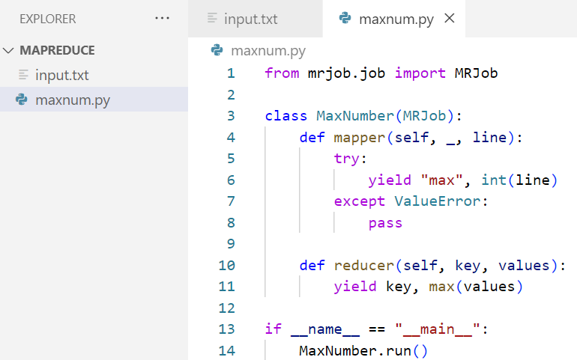

**INPUT FILE:**

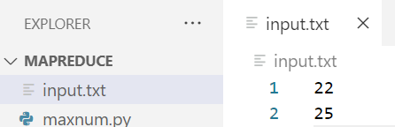

**OUTPUT:**

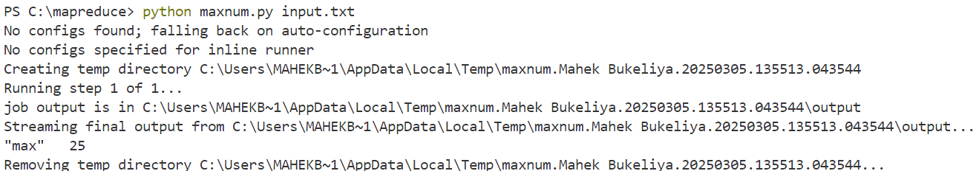

**4] MINIMUM NUMBER**

**CODE:**

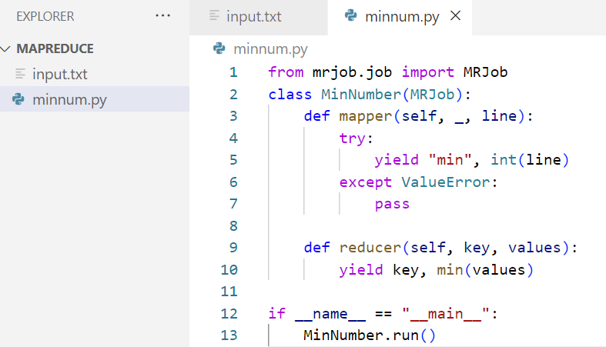

**INPUT FILE:**



**OUTPUT:**

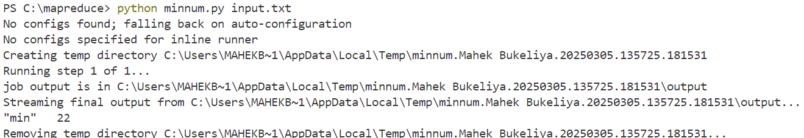

**5] SORT NUMBERS**

**CODE:**

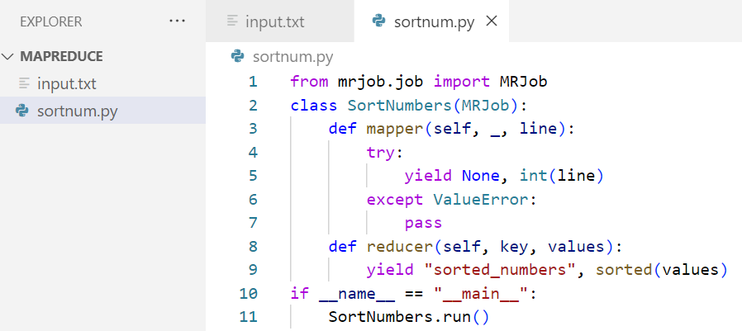

**INPUT FILE:**

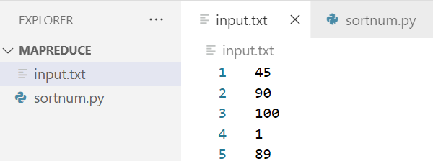

**OUTPUT:**

